REINFORCEMENT LEARNING (RL) FRAMEWORK
1. Introduction to Reinforcement Learning
Reinforcement Learning (RL) is a type of Machine Learning where an agent learns how to behave in an environment by performing actions and receiving rewards or penalties.
Instead of being taught the correct answer, the system learns from experience through trial and error.
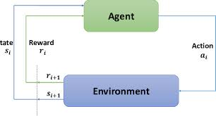
Simple idea:
- Do an action
- See the result
- If the result is good → repeat it
- If the result is bad → avoid it
2. Basic Idea of RL
Reinforcement learning is inspired by human learning.
Example:
Imagine teaching a dog to sit.
- Dog sits → give treat (reward)
- Dog jumps → no treat (penalty)
After some time, the dog learns which action gives the best reward.
Similarly, RL algorithms learn which actions maximize rewards.
3. Components of Reinforcement Learning Framework
The RL framework mainly consists of five elements.
1. Agent
The learner or decision maker.
Example:
- Robot
- Self-driving car
- Game playing AI
- Recommendation system
Example
In a chess game → the AI player is the agent
2. Environment
Everything outside the agent that the agent interacts with.
The environment:
- receives actions from the agent
- returns new state and reward
Example
In chess → the chessboard and opponent are the environment.
3. State (S)
A state represents the current situation of the environment.
Example:
- Position of pieces in chess
- Location of robot in a room
- Position of player in a video game
State answers the question:
“Where am I right now?”
4. Action (A)
An action is something the agent can do.
Example:
- Move left
- Move right
- Pick an item
- Attack enemy
- Make a chess move
Actions change the state of the environment.
5. Reward (R)
A reward is feedback given to the agent after performing an action.
Rewards help the agent learn which actions are good.
Examples:
- +10 points → correct action
- -5 points → wrong action
Example
In a game:
- Win → +100 reward
- Lose → -100 reward
4. RL Interaction Cycle
The reinforcement learning process works in a continuous loop.
Steps:
- Agent observes current state (S)
- Agent chooses an action (A)
- Environment changes
- Environment gives reward (R)
- Environment gives next state (S')
- Agent learns from reward
This cycle repeats many times.
5. Goal of Reinforcement Learning
The goal of the agent is to maximize total reward over time.
This means the agent must learn a strategy that gives the highest long-term reward.
Not just immediate reward.
Example:
Imagine a maze game.
Two choices:
Path A:
- Reward now = 5
Path B:
- Reward now = 1
- Reward later = 50
A good RL agent chooses Path B because total reward is higher.
INTELLIGENT AGENTS
DEFINITION OF AN INTELLIGENT AGENT
An Intelligent Agent is a system that perceives its environment through sensors and acts upon that environment using actuators in order to achieve a goal.
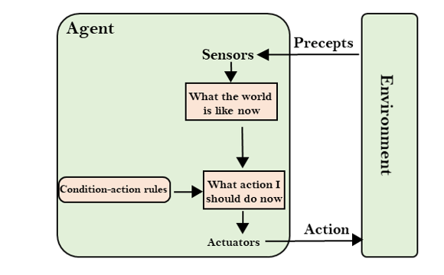
Simple meaning:
An intelligent agent is something that observes, thinks, and acts to achieve a goal.
2. Basic Idea
An intelligent agent works in three steps:
- Perceive the environment
- Decide what action to take
- Act on the environment
This cycle continues continuously.
STRUCTURE OF AN INTELLIGENT AGENT
An intelligent agent has three main parts:
1. Sensors
Sensors help the agent observe the environment.
Examples:
- Camera
- Microphone
- GPS
- Temperature sensor
Example
A self-driving car uses:
- cameras
- radar
- lidar
to sense the surroundings.
2. Agent Program (Brain)
This is the decision-making part.
The program:
- processes sensor data
- decides the best action
Example:
- AI algorithm
- Machine learning model
- rule-based system
3. Actuators
Actuators allow the agent to perform actions.
Examples:
- wheels
- robotic arms
- speakers
- motors
Example
A robot arm uses motors to move objects.
4. Agent Function
An Agent Function maps percepts (inputs) to actions.
Mathematically:
Agent Function
Percept → Action
Meaning:
The agent receives information about the environment and decides what action to take.
TYPESOF AGENTS:
- Simple Reflex Agents
- Model-Based Reflex Agents
- Goal-Based Agents
- Utility-Based Agents
- Learning Agent
1.Simple Reflex Agents:
- This is the simplest agent which selection on the basis of the current percent by ignoring the rest of the person history.
- In this problem the decision is based on the current location and on whether it contains dirt.
A condition-action rule maps a state (condition) to an action.
- If the condition is true, the associated action is performed.
- If the condition is false, no action is taken.
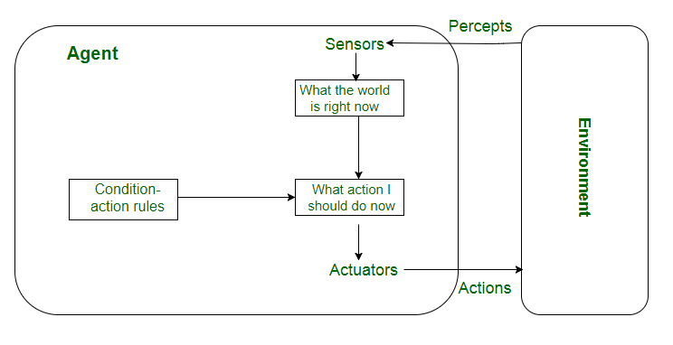

2. Model-Based Reflex Agents
- A model based agent can handle a partially deserving environment and track the situation
- The agent maintain some internal state that depends on the perspective history and it has some of the observed aspect of the current state
Eg: Automated taxi.
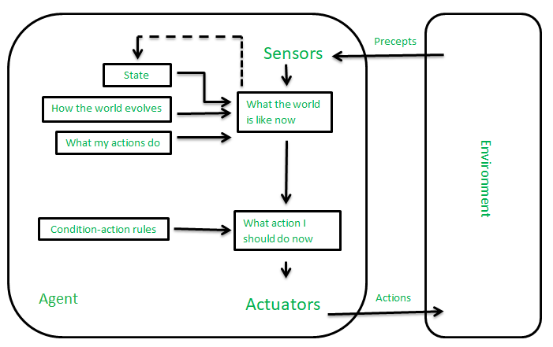
3.Goal-Based Agents:
- Goal-based agents make decisions based on their current distance from the goal and every action the agent aims to reduce the distance from goal.
- They can choose from multiple possibilities, selecting the one that best leads to the goal state.
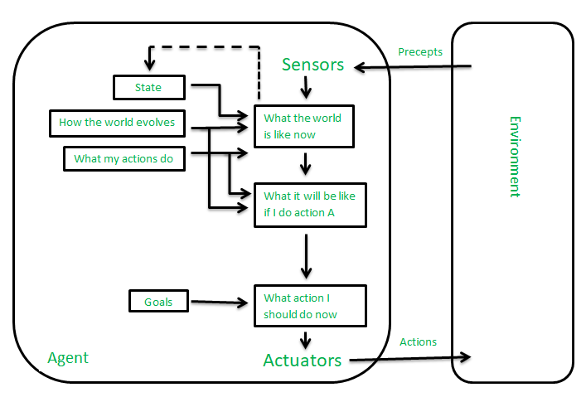
4.Utility-Based Agents
- A agent that generates a good state with high quality behavior in most environment is called utility-based agent
Eg: automated tax
- These agents assess multiple alternatives and choose the one that maximizes their utility, which is a measure of how desirable or “happy” a state is for the agent.

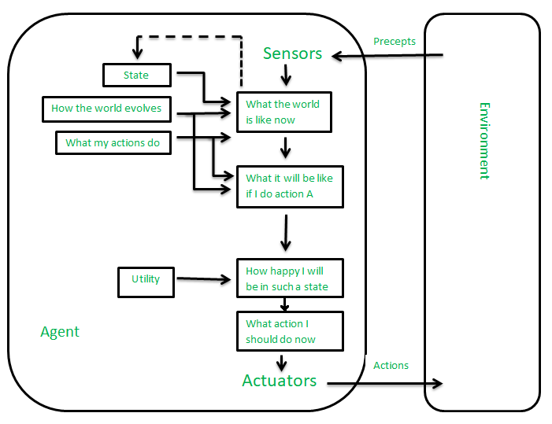
5.Learning Agent:
- The learning task allow the agent to operate in unknown environment initially an become more competent that its initial knowledge.
- Responsible for making the environment to improve , it uses critic to better the future.
- Performance element : It is responsible for selecting external action.
- Critic: Observes world and it gives feedback to learning agent and how the agent is doing and it determine how the performance element should be modified in future.
- Problem Generation: Suggesting action that will lead to new and information experiences.
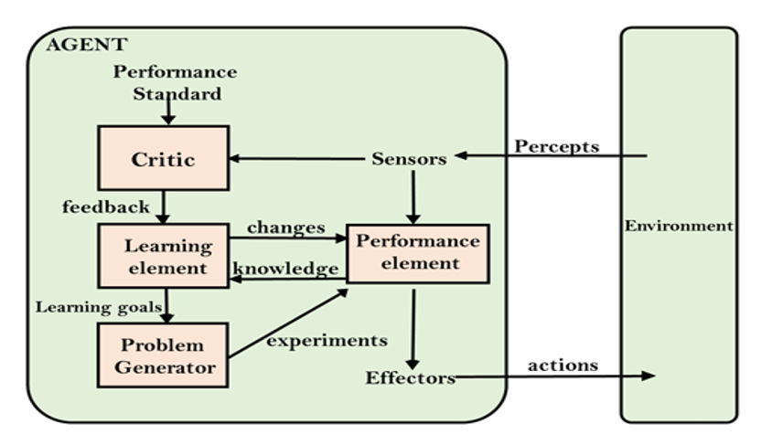

Example of Intelligent Agent
Example 1: Self Driving Car
Sensors:
- Cameras
- Radar
- GPS
Agent program:
- AI driving system
Actuators:
- Steering wheel
- Brakes
- Accelerator
Process:
- Car detects road
- AI analyzes traffic
- Car decides to slow down
- Brakes applied
PROBLEM SOLVING IN ARTIFICIAL INTELLIGENCE
INTRODUCTION TO PROBLEM SOLVING
In Artificial Intelligence, problem solving refers to the process where an AI system finds a sequence of actions that leads from an initial state to a goal state.
Simple meaning:
Problem solving is finding the best solution or path to reach a goal.
AI systems solve problems by:
- analyzing the situation
- exploring possible actions
- choosing the best path to reach the goal.

Example: Chess Game
Initial state → Starting board position
Goal state → Checkmate
Actions → Legal chess moves
The AI must determine the sequence of moves that leads to winning.
COMPONENTS OF A PROBLEM
In AI, a problem is defined using five main components.
1. Initial State
The starting point of the problem.
Example:
- Robot starting position
- Initial chess board setup
2. State Space
The set of all possible states that can occur during problem solving.
Example:
In chess:
- Every possible board configuration.
In a maze:
- Every possible position in the maze.
3. Actions (Operators)
Actions define how the agent moves from one state to another.
Example:
In a maze:
- move left
- move right
- move up
- move down

4. Goal State
The desired final state the agent wants to reach.
Example:
- Maze exit
- Winning the chess game
- Finding the shortest route
5. Path Cost
The cost associated with moving from one state to another.
Example:
- Distance
- Time
- Energy
The goal is usually to minimize the path cost.
CHARACTERISTICS OF PROBLEM SOLVING AGENTS
Problem solving agents usually work in environments that are:
1. Fully Observable
Agent can see the entire environment.
Example:Chess board.
2. Deterministic
Actions produce predictable results.
Example: Puzzle solving.
3. Discrete
Limited number of states and actions.
Example: Board games.
4. Static
Environment does not change while solving the problem.
Example: Sudoku puzzle.

SEARCH IN PROBLEM SOLVING
Problem solving in AI mainly uses search algorithms.
The agent searches through the state space to find a solution.
Common search algorithms include:
- Breadth First Search (BFS)
- Depth First Search (DFS)
- A* Search
- Greedy Search
These algorithms help the agent explore possible solutions efficiently.
TYPES OF PROBLEMS IN AI
AI problems are classified into several types.
1. Single-State Problems
The agent knows the exact state.
Example: Chess game.
2. Multiple-State Problems
The agent is uncertain about the environment.
Example: Robot navigating with incomplete information.
3. Contingency Problems
The environment may change unpredictably.
Example: Self-driving car reacting to traffic.
4. Exploration Problems
The agent must explore the environment to learn about it.
Example: Robot exploring a new building.

SEARCHING IN ARTIFICIAL INTELLIGENCE
INTRODUCTION TO SEARCHING
- Searching is the process of finding a sequence of actions that leads from an initial state to a goal state.
- In AI, searching is used when the agent does not know the exact solution, so it must explore different possibilities.
Simple meaning:
Searching means looking through possible states to find the goal.
EXAMPLE OF SEARCHING
Example: Maze Problem
Imagine a robot inside a maze.
- Start → Initial state
- Exit → Goal state
- Possible moves → Actions
The robot tries different paths until it finds the exit.
This process is called searching.
SEARCH SPACE
- The search space is the set of all possible states that can be explored to solve a problem.
Example:
In chess:
- Every possible board position forms the search space.
In a maze:
- Every possible location in the maze.
TYPES OF SEARCHING
1.Uninformed Search (Blind Search)
- Uninformed search algorithms do not know where the goal is.
- They explore the search space systematically until they find the goal.

Examples:
- Breadth First Search (BFS)
- Depth First Search (DFS)
Breadth First Search (BFS)
Definition
Breadth First Search explores the search tree level by level, checking all nodes at the current depth before moving to the next level.
Working
- Start from the root node.
- Visit all nodes at level 1.
- Then visit nodes at level 2.
- Continue until the goal is found.
It uses a Queue (FIFO).
Example
Search tree:
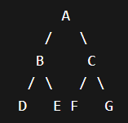
Goal = F
Steps:
- Start at A
- Visit B, C
- Visit D, E, F, G
- Goal F found
Traversal order : A → B → C → D → E → F
Depth First Search (DFS)
Definition
Depth First Search explores a branch as deep as possible before backtracking.
Working
- Start from root.
- Go deep into one branch.
- If dead end occurs, backtrack.
- Explore next branch.
It uses a Stack (LIFO).
Example
Search tree:
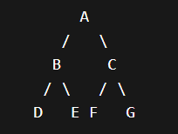
Goal = F
Steps:
- Start A
- Go to B
- Go to D
- Backtrack
- Go to E
- Backtrack
- Go to C
- Go to F (Goal)
Traversal order: A → B → D → E → C → F

2.Informed Search (Heuristic Search)
- Informed search uses extra information called a heuristic.
- A heuristic function h(n) estimates the distance from the current node to the goal.
Examples:
- Greedy Best First Search
- A* Search
These searches are faster because they use guidance.
Greedy Best-First Search
Definition
- Greedy Best First Search selects the node that appears closest to the goal based on heuristic value.
Evaluation function:
f(n) = h(n)
where
h(n) = estimated distance to goal.
Example
Graph:
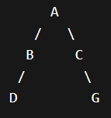
Heuristic values (distance to goal G):
A = 5
B = 4
C = 2
D = 6
G = 0
Steps:
- Start at A
- Choose node with lowest heuristic → C
- From C → G
Path found: A → C → G
A* Search
Definition
A* search finds the optimal path by considering both:
- actual cost from start
- estimated cost to goal
Evaluation function:
f(n) = g(n) + h(n)
Where:
g(n) = cost from start to node
h(n) = estimated cost to goal
Example
Graph:
A --1--> B --2--> D
A --4--> C --1--> D
Heuristic values:
B → D = 2
C → D = 1
Calculation:
For B:
f(B) = g(B) + h(B)
= 1 + 2 = 3
For C:
f(C) = 4 + 1 = 5
So A* chooses:
A → B → D
because 3 < 5

Search | Idea | Uses
BFS | Level by level | Shortest path (unweighted)
DFS | Go deep first | Maze solving
Greedy | Closest to goal | Fast navigation
A* | Cost + heuristic | Optimal path finding

PROBABILITY AXIOMS
1. Introduction to Probability
Probability is a measure of how likely an event is to occur.
It is widely used in:
- Artificial Intelligence
- Machine Learning
- Data Science
- Decision making under uncertainty
Simple meaning:
Probability tells us how likely something will happen.
The value of probability lies between:
0 ≤ P(A) ≤ 1
Where:
- 0 → event will never happen
- 1 → event will definitely happen
Example:
Probability of getting head in a coin toss = 0.5
Basic Terms in Probability
Experiment
- An action that produces outcomes.
Example:
- Tossing a coin
- Rolling a dice

Sample Space (S)
- The set of all possible outcomes of an experiment.
Example:
Rolling a dice
S = {1,2,3,4,5,6}
Event
- An event is a subset of the sample space.
Example:
Event A = getting an even number
A = {2,4,6}
Axioms of Probability
- The Axioms of Probability were defined by the mathematician Andrey Kolmogorov.
- These axioms are the basic rules of probability.
There are three main axioms.
Axiom 1: Non-Negativity
The probability of any event is always greater than or equal to zero.
P(A) ≥ 0
This means probability can never be negative.
Example
Probability of getting head in a coin toss:
P(head) = 0.5
which is ≥ 0.
Axiom 2: Normalization
The probability of the entire sample space is 1.
P(S) = 1
This means the probability that some outcome will occur is certain.
Example
Rolling a dice:
S = {1,2,3,4,5,6}
The probability that one of these numbers occurs is 1.
Axiom 3: Additivity
If two events cannot occur at the same time (mutually exclusive) then:
P(A ∪ B) = P(A) + P(B)
This means the probability of either event occurring is the sum of their probabilities.
Example
Rolling a dice.
Event A = getting 2
Event B = getting 5
P(A) = 1/6
P(B) = 1/6
So:
P(A ∪ B) = 1/6 + 1/6
= 2/6
= 1/3
Important Probability Rules Derived from Axioms
From these axioms we derive important rules.
1. Complement Rule
The probability that event A does not occur is:
P(A') = 1 − P(A)
Example:
Probability of rain today = 0.7
Probability of no rain:
P(no rain) = 1 − 0.7
= 0.3
2. Union Rule
For two events:
P(A ∪ B) = P(A) + P(B) − P(A ∩ B)
Where:
A ∩ B = both events happen.
Example
Probability of student liking:
Math = 0.6
Science = 0.5
Both = 0.3
Then:
P(Math ∪ Science)
= 0.6 + 0.5 − 0.3
= 0.8
RANDOM VARIABLES, PMF, AND PDF
RANDOM VARIABLE
Definition
- A Random Variable is a variable whose value is determined by the outcome of a random experiment.
- In simple words, it is a numerical value assigned to each possible outcome of a random experiment.
- Random variables are usually represented by capital letters like: X, Y, Z
Example 1: Coin Toss
Experiment: Toss a coin
Sample space:
S = {Head, Tail}
Let random variable X represent the outcome.
X = 1 if Head
X = 0 if Tail
So the random variable converts outcomes into numbers.
Example 2: Rolling a Dice
Experiment: Roll a dice
Random variable X = number that appears on the dice.
Possible values of X:
X = {1,2,3,4,5,6}
TYPES OF RANDOM VARIABLES
There are two main types.
1. Discrete Random Variable
A random variable that takes countable values.
Examples:
- number of heads in coin toss
- number of students in a class
- number of cars in parking
Example:
Rolling a dice:
X = {1,2,3,4,5,6}
These values are countable, so it is discrete.
2. Continuous Random Variable
A random variable that takes infinite values within a range.
Examples:
- height of a person
- temperature
- weight
- time taken to complete a task
Example:
Temperature could be:
25.1°C
25.15°C
25.156°C
These values are continuous.

PROBABILITY MASS FUNCTION (PMF)
1. Definition
- A Probability Mass Function (PMF) describes the probability that a discrete random variable takes a specific value.
- In simple words, PMF tells us the probability of each possible value of a discrete variable.
Mathematically:
$$P(X=x)$$
Where:
- X = Random variable
- x = Specific value of the random variable
WHEN PMF IS USED
- PMF is used only for discrete random variables.
- A discrete random variable takes countable values.
Examples:
- Number of heads in coin toss
- Number of students in a class
- Number obtained when rolling a dice
- Number of defective items in a batch

Example of PMF (Dice Example)
Consider an experiment of rolling a fair dice.
Random variable:
X = number obtained on dice.
Possible values:
X = {1,2,3,4,5,6}
Since the dice is fair:
$$P(X=1)=1/6 \\ P(X=2)=1/6 \\ P(X=3)=1/6 \\ P(X=4)=1/6 \\ P(X=5)=1/6 \\ P(X=6)=1/6$$
PMF table:
X | P(X)
1 | 1/6
2 | 1/6
3 | 1/6
4 | 1/6
5 | 1/6
6 | 1/6

Graph of PMF
- A PMF graph usually looks like vertical bars.
- Each bar represents the probability of a particular value.
Example:
For dice:
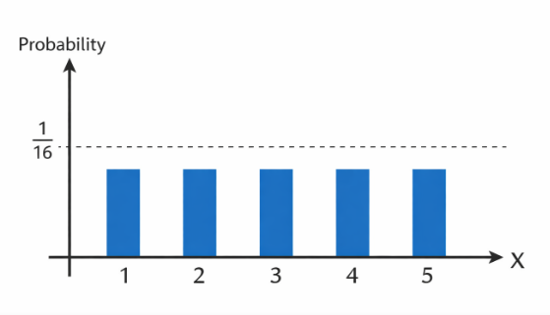
Each bar represents P(X=x).
PROPERTIES OF PMF
Property 1: Non-negative probability
$$P(X=x)≥0$$
Probability cannot be negative.
Property 2: Total probability equals 1
$$∑P(X=x)=1$$
The sum of probabilities of all outcomes must equal 1.
Example:
$$1/6+1/6+1/6+1/6+1/6+1/6=1$$
Property 3: Probability is defined for specific values
PMF gives probability exactly at a particular value.
Example:
$$P(X=3)=1/6$$
Applications of PMF
PMF is used in many fields:
- Machine learning
- Risk analysis
- Data science
- Quality control
- AI probabilistic models
Example:
Predicting number of failures in a system.
PROBABILITY DENSITY FUNCTION (PDF)
Definition
- A Probability Density Function (PDF) describes the probability distribution of a continuous random variable.
- Instead of giving probability for a single value, it gives the probability over a range (interval).
Mathematically: $f(x)$ represents the probability density function.
When PDF is Used
- PDF is used for continuous random variables.
- Continuous variables can take infinite values within a range.
Examples:
- Height of people
- Temperature
- Time
- Weight
- Speed
Example:
Height could be:
170 cm
170.2 cm
170.25 cm
170.256 cm
There are infinitely many possible values.
Important Concept of PDF
For continuous variables:
$$P(X=x)=0$$
The probability of a single exact value is zero.
Instead we calculate probability over an interval.
Example:
$$P(160<X<170)$$
This means the probability that height is between 160 cm and 170 cm.

4. Graph of PDF
A PDF graph is usually a smooth curve.
Example:
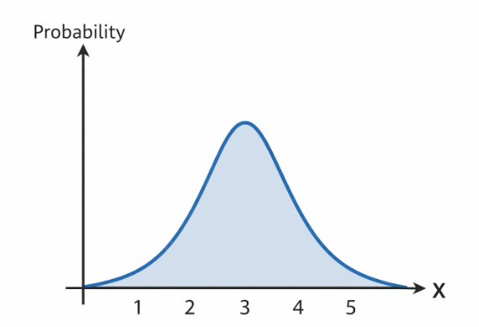
The area under the curve represents probability.
Properties of PDF
Property 1: Non-negative density
$$f(x)≥0$$
The density function cannot be negative.
Property 2: Total area equals 1
The total area under the PDF curve must equal 1.
$$\int_{-∞}^{∞}{f(x)dx=1}$$
Property 3: Probability over an interval
Probability is calculated using integration.
$$P(a≤X≤b)=\int_{a}^{b}{f(x)dx}$$
6. Example of PDF
Example: Uniform Distribution
Suppose waiting time for a bus is between 0 and 10 minutes.
PDF:
$$f(x)=\frac{1}{10},0≤x≤10$$
Probability that waiting time is between 2 and 5 minutes:
$$P(2≤X≤5)=\frac{5-2}{10}=3/10$$
7. Applications of PDF
PDF is widely used in:
- Machine learning
- Statistics
- Data analysis
- AI models
- Signal processing
Key Difference Between PMF and PDF
Feature | PMF | PDF
Used for | Discrete variables | Continuous variables
Function | P(X=x) | f(x)
Values | Countable | Infinite
Graph | Bars | Smooth curve
Probability | Exact value | Interval

AGENT–ENVIRONMENT INTERFACE
Definition
- The Agent–Environment Interface describes how an agent interacts with its environment.
- It explains how the agent receives information from the environment and how it performs actions that affect the environment.
Simple definition :
- The Agent–Environment Interface is the interaction mechanism through which an agent observes the environment using sensors and acts upon it using actions or actuators.
Basic Idea
In Reinforcement Learning, the agent and environment interact continuously.
The agent:
- observes the environment
- takes an action
- receives feedback
This feedback helps the agent learn better actions over time.
Components of the Agent–Environment Interface
The interface mainly consists of four elements:
1. Agent
The decision maker or learner.
Examples:
- Robot
- Self-driving car
- AI game player
- Recommendation system
The agent's job is to select actions.
2. Environment
Everything outside the agent that it interacts with.
Examples:
- Road and traffic for a self-driving car
- Chess board in a chess game
- Game world in a video game
The environment changes based on the agent’s actions.
3. State (S)
The state represents the current condition of the environment.

Example:
In a chess game:
State = arrangement of pieces on the board.
In a robot navigation task:
State = robot’s location and surroundings.
4. Action (A)
An action is something the agent can perform.
Examples:
- move left
- move right
- pick object
- accelerate car
The action changes the state of the environment.
Interaction Process
The agent and environment interact in steps called time steps.
At each step:
- Agent observes the state (S)
- Agent selects an action (A)
- Environment changes
- Environment gives reward (R)
- New state (S') is returned
This process continues repeatedly.
Agent–Environment Interaction Cycle
The interaction can be represented as:
Environment → State → Agent
Agent → Action → Environment
Environment → Reward → Agent
This loop continues until the task is finished.

Example of Agent–Environment Interface
Example: Self Driving Car
Agent: Autonomous driving system.
Environment:
Road, traffic lights, pedestrians.
State:
Car position, speed, nearby vehicles.
Action:
- accelerate
- brake
- turn left
- turn right
Reward:
- safe driving → positive reward
- collision → negative reward
Importance of Agent–Environment Interface
The interface is important because it:
- allows the agent to observe the environment
- allows the agent to take actions
- provides feedback through rewards
- helps the agent learn optimal behaviour
Without this interaction, learning cannot occur.
Applications
Agent–Environment interaction is used in:
- Robotics
- Autonomous vehicles
- Game AI
- Smart assistants
- Recommendation systems
GOALS, REWARDS, RETURNS, POLICIES, AND VALUE FUNCTION
- These are core concepts in Reinforcement Learning (RL).
- They define how an agent learns to make decisions and improve its behavior through interaction with the environment.
- In RL, the agent tries to learn a strategy that maximizes the total reward it receives over time.
1. Goals
Definition
A goal is the desired objective or outcome that the agent tries to achieve through its actions.
In reinforcement learning, the goal is usually defined in terms of maximizing cumulative reward.
Simple meaning:
The goal is what the agent ultimately wants to achieve.
Example 1: Robot Navigation
Agent → Robot
Environment → Building or maze
Goal → Reach the destination.
The robot must choose movements that lead it closer to the goal.
Goal Representation in RL
Unlike traditional AI, reinforcement learning does not always define a goal explicitly.
Instead, the goal is expressed through rewards.
Example:
+100 → reach destination
-50 → collision
The agent learns that reaching the destination is the desired goal.
2. Reward
Definition
- A reward is a numerical signal given by the environment to the agent after each action.
- It indicates how good or bad the action was.
Simple meaning:
Reward is feedback that tells the agent whether its action was good or bad.
Purpose of Reward
The reward guides the agent to:
- learn good behavior
- avoid bad actions
- improve performance
The agent always tries to maximize rewards.
Types of Rewards
1. Positive Reward
Given when the agent performs a correct or desirable action.
Example:
Game AI wins → +100 points
2. Negative Reward (Penalty)
Given when the agent performs an undesirable action.
Example:
Robot hits obstacle → -10
3. Zero Reward
Some actions may produce no reward.
Example:
Robot moving in an empty hallway.
Example: Robot Cleaning
Action | Reward
Clean dirt | +10
Move normally | 0
Hit obstacle | -5
The agent learns that cleaning dirt is beneficial.
3. Return
Definition
- The return is the total cumulative reward that the agent receives over time.
- It represents the sum of rewards from the current time step until the end of the task.
- Return is usually denoted by: Gₜ
Mathematical Formula
$$G_{t}=R_{t+1}+R_{t+2}+R_{t+3}+...$$
Where:
- Gₜ = Return at time t
- R = Reward received at each step
Discounted Return
- Future rewards are often discounted, meaning rewards received later are considered slightly less important.
Formula:
$$G_{t}=R_{t+1}+γR_{t+2}+γ^{2}R_{t+3}+...$$
Where:
γ (gamma) = discount factor
Range:
0 ≤ γ ≤ 1
Meaning of Discount Factor
γ value | Meaning
γ = 0 | Only immediate reward matters
γ close to 1 | Future rewards also important

Example
Suppose rewards are:
Step | Reward
1 | 10
2 | 20
3 | 30
Return:
G = 10 + 20 + 30 = 60
4. Policy
Definition
- A policy is a rule or strategy that determines which action the agent should take in each state.
It is usually represented by:
π (pi)
Mathematically:
$$π(a∣s)$$
This means: Probability of taking action a in state s.
Purpose of Policy
Policy guides the agent to choose actions that maximize long-term rewards.
The goal of reinforcement learning is to find the optimal policy.
Types of Policies
1. Deterministic Policy
Each state has only one action.

Example:
State | Action
Red traffic light | Stop
Green light | Move

2. Stochastic Policy
Each action has a probability.
Example:
State | Action | Probability
S1 | Move left | 0.7
S1 | Move right | 0.3

Example
Robot navigation.
State = robot location
Policy = move toward the shortest path.
5. Value Function
Definition
- A value function estimates how good it is for the agent to be in a particular state.
- It predicts the expected future reward starting from that state.
Simple meaning:
Value function measures the long-term usefulness of a state.
Types of Value Functions
1. State Value Function
Represented by:
V(s)
It gives the expected return if the agent starts in state s and follows policy π.
Mathematically:
$$V_{π}(s)=E_{π}[G_{t}∣S_{t}=s]$$
Meaning:
Expected return starting from state s.
2. Action Value Function
Represented by:
Q(s,a)
It gives the expected return after taking action a in state s.
Mathematically:
$$Q_{π}(s,a)=E_{π}[G_{t}∣S_{t}=s,A_{t}=a]$$
This is widely used in algorithms like Q-learning.
Example
Game AI.
State = board position.
Value function estimates:
- how likely the agent is to win
- expected future rewards.
Example Combining All Concepts
Imagine a robot in a maze.
- Goal : Reach the exit.
- State : Robot's position.
- Action : Move up, down, left, right.
- Reward: +100 for reaching goal
-10 for hitting wall.
- Policy : Move toward the exit.
- Value Function : Estimate which states lead to the highest future rewards.
- Return : Total rewards collected along the path.

NOTATION FOR EPISODIC AND CONTINUING TASKS
- This topic explains how Reinforcement Learning problems are represented mathematically over time.
- In RL, the interaction between agent and environment happens step by step over time.
Each step is called a time step.
1. Time Step Notation
In reinforcement learning, time is represented as:
t = 0, 1, 2, 3, ...
At each time step t, the agent interacts with the environment.
The following symbols are commonly used:
Symbol | Meaning
Sₜ | State at time t
Aₜ | Action taken at time t
Rₜ₊₁ | Reward received after action
Sₜ₊₁ | Next state

Example of Time Step Interaction
Step | State | Action | Reward | Next State
t | Sₜ | Aₜ | Rₜ₊₁ | Sₜ₊₁
This sequence repeats continuously as the agent interacts with the environment.

2. Episodic Tasks
Definition
- An episodic task is a task that has a clear beginning and a clear end.
- The agent interacts with the environment for a limited number of steps called an episode.
- When the task is finished, the episode ends and a new episode begins.
Characteristics
- Finite sequence of states
- Has a terminal state
- Interaction resets after completion
Example 1: Game Playing
Game start → episode begins
Game ends → episode ends
Example:
- Chess
- Tic-tac-toe
- Video games
Each game is one episode.
Representation of an Episode
An episode can be written as:
S₀ → A₀ → R₁ → S₁ → A₁ → R₂ → S₂ → ... → Sₜ
Where the last state is the terminal state.
3. Terminal State
The terminal state is the final state where the episode ends.
After reaching this state:
- no more actions are taken
- the environment resets.
Example:
Game result:
Win / Lose → terminal state.
4. Continuing Tasks
Definition
- A continuing task is a task that does not have a natural ending point.
- The agent interacts with the environment continuously without stopping.

Characteristics
- No terminal state
- Runs indefinitely
- Long-term performance is important
Example 1: Robot Monitoring System
A robot monitoring a factory works continuously without stopping.
There is no final state.
5. Return in Episodic Tasks
For episodic tasks, return is calculated until the end of the episode.
Formula:
Gₜ = Rₜ₊₁ + Rₜ₂ + Rₜ₃ + ... + Rₜ₊T
Where:
T = final time step of the episode.
6. Return in Continuing Tasks
For continuing tasks, the episode never ends, so we use discounted return.
$$G_{t}=R_{t+1}+γR_{t+2}+γ^{2}R_{t+3}+...$$
Where:
γ = discount factor (0 ≤ γ ≤ 1)
Discounting ensures the infinite reward sum remains finite.
COMPARING EPISODIC AND CONTINUING TASKS
Feature | Episodic Task | Continuing Task
End state | Yes | No
Duration | Finite | Infinite
Example | Chess game | Robot monitoring
Return calculation | Until episode end | Discounted infinite return

